Flash Memorizer: Requirements Document (version 1.0)

Project: Flash Memorizer
Date(s): 08/23/2021
Prepared by: Michael Tadese

Document status: _X_ Draft _X_ Proposed __ Validated __ Approved

1. Introduction
This document contains the system requirements for Flash Memorizer. These requirements have been derived from several sources, including https://www.educationalappstore.com/best-apps/6-best-flashcard-apps & https://medium.com/@ashikabala01/how-to-build-login-and-sign-up-functionality-for-your-ios-app-using-firebase-within-15-mins-df4731faf2f7

1.1 Purpose of This Document
This document is intended to guide development of Flash Memorizer. It will go through several stages during the course of the project:
- Draft: The first version, or draft version, is compiled after requirements have been discovered, recorded, classified, and prioritized.
- Proposed: The draft document is then proposed as a potential requirements specification for the project. The proposed document should be reviewed by several parties, who may comment on any requirements and any priorities, either to agree, to disagree, or to identify missing requirements. Readers include end-users, developers, project managers, and any other stakeholders. The document may be amended and reproposed several times before moving to the next stage.
- Validated: Once the various stakeholders have agreed to the requirements in the document, it is considered validated.
- Approved: The validated document is accepted by representatives of each party of stakeholders as an appropriate statement of requirements for the project. The developers then use the requirements document as a guide to implementation and to check the progress of the project as it develops.

1.2 How to Use This Document
We expect that this document will be used by people with different skill sets. This section explains which parts of this document should be reviewed by various types of readers.

Types of Reader
This SRS document is produced for interactors with the app such as project manager, project evaluator, project developer and users. Section 1 is focused on information relevant mainly for the project evaluator and project developer, while section 2 contains information for all interactors, mainly for users. Users can focus on section 2 to understand the functionality and the main idea of the project.

Technical Background Required
This SRS document requires readers to be equipped with at least beginner level computer programming knowledge to easily comprehend and map out how the project will proceed. Section 2.4 will require simple computer/electronic knowledge from the reader.

Overview Sections
To gain an overall understanding of this project, readers should refer to sections 1.3(Scope of the product) and 2.2(Product functions).

Reader-Specific Sections
Information from section 1 such as required technical background, scope of the product and business case for the product are mainly intended for the project evaluator and project developer therefore can be skipped by interactors such as users. Users can focus on topics from section 2 such as product functions, user characteristics and product perspective.
Section Order Dependencies
Although there is no specific order readers are required to follow, it is recommended that readers begin with section 1.3 Scope of the product to get a brief idea what the document is about then proceed in the order of the numbering.

1.3 Scope of the Product
Students starting from elementary school all the way through graduate school have relied on paper flash cards when preparing for an exam or other reasons to test and improve their memory through practiced information retrieval. Although using paper flash cards is an effective way for studying, it also has a disadvantage of paper waste, students losing their flashcards and limits students from using it as long as they desire. So, I came up with an idea to save paper wastage and give students more flexibility with their flashcards. Flash Memorizer is aimed to help users store, organize, and build their flash cards throughout the semester or even a year and make it accessible at any time as long as users have their smart phones with them.

1.4 Business Case for the Product
The main purpose of Flash Memorizer is to give students a more flexible and accessible way to build and utilize their flashcards throughout the school year or semester. This will have an important role in helping students achieve an overall higher score in their test and quizzes. Flash Memorizer can be provided to students by institutions.

1.5 Overview of the Requirements Document
This document provides a brief description of the application Flash Memorizer in various sections of the document by explaining the motivation and reason why Flash Memorizer is developed, what it is consisted of and what it provides to its users. Some of the important sections of this document are sections 1.3 Scope of the product, 2.1 Product Perspective, 2.2 Product Functions, 3.1 User Requirements and 3.2 System Requirements. Readers should focus on these sections to understand in depth of what Flash Memorizer is all about.

2. General Description
This section will give the reader an overview of the project, including why it was conceived, what it will do when complete, and the types of people we expect will use it. We also list constraints that were faced during development and assumptions we made about how we would proceed.

2.1 Product Perspective
I have chosen to develop Flash Memorizer because I personally have experienced constantly losing my flashcards after a single use, wasting paper and time when I have to remake them, and being unable to easily have it in my hand when I want to study again. Flash Memorizer will make sure to resolve these problems, save time and make it easier for students and users to use their traditional way of studying on their smart phones. The primary stakeholders of this project are, the program evaluator (Dr. Iyangar), the users(students) and the program developer (Michael Tadese). Students who regularly utilize paper flashcards for their studies will benefit greatly from Flash Memorizer.
2.2 Product Functions
Flash Memorizer will allow students to utilize flashcards from their smartphones for their studies without wasting papers. Users will easily be able to generate, access and organize their various flashcards throughout the semester.

Flash Memorizer will have the following functions: Flash Memorizer will
- display a login page requiring users to create an account or log into an existing account to proceed—collects information such as email, name & phone number to save progress for returning users.
- display a plus sign key for the user to create and generate a new flashcard
- collect information from the user to store on the new flashcard – key terms, definitions, equations….
- display generated flashcards in different sort orders such as alphabetical, date created, and date modified.
- display a plus sign option to create a new folder for the flashcards – a folder to organize the flashcards in groups, subjects, classes….
- allow users to easily add and organize the generated flashcards in their desired folders.
- display the generated folders that consist of the flash cards to the user in a desired sort order.
- display flash cards from selected folder or individual flashcards for easy access – will generate a simple and visible preview of the created flashcards.
- easily edit, add, store, or delete flashcards as desired by the user.
- display a search bar for users to easily locate existing flashcards or groups by either typing the title of the flash card or the name of the folder the flashcard belongs to.

2.3 User Characteristics
Users mainly consisted of students are expected to utilize Flash Memorizer throughout their educational studies because Flash Memorizer is mainly aimed in benefiting students. Basic smartphone usage experience such as downloading apps, reading, and accessing applications is required to use this program. If good internet connection is available to download the application, users shall not encounter any other obstacles.

2.4 General Constraints
Flash Memorizer is developed using a development environment known as Swift. Flash Memorizer is compatible for both android and iOS smartphones.

2.5 Assumptions and Dependencies
It is assumed that Flash Memorizer will be delivered over the internet through play store for android users and the app store for iOS users.

3. Specific Requirements
This section of the document lists specific requirements for Flash Memorizer. Requirements are divided into the following sections:
- User requirements. These are requirements written from the point of view of end users, usually expressed in narrative form.
- System requirements. These are detailed specifications describing the functions the system must be capable of doing.
- Interface requirements. These are requirements about the user interface, which may be expressed as a list, as a narrative, or as images of screen mock-ups.

3.1 User/System Requirements

    - The system shall have a login page for users to create an account or login into an existing account to proceed into the application. (Non-Functional Requirements)

      - The system shall require personal information such as Name, Email, Password from first time users to create an account.
      - The system shall require users to accept the user agreements before proceeding to the account.
      - The system shall recognize existing account and prevent users from creating a new account with the same credentials and prompt users to login instead.
      - The system shall require email and password for returning and newly registered users for login.
      - The system shall allow users to login into their accounts when the correct credentials are inputted.
      - The system should not allow users to login into their accounts if incorrect credentials are provided by the users.
      - The system shall ask users to reset their password or create a new account.
      - The system shall allow users to reset their passwords by sending a code or a link to email provided.
      - The system shall allow users to log out of their account when complete.

    - The system shall be able to collect the required information from users to generate the new flashcard. (Functional Requirements)

      - The system shall display a plus icon button that allows users to start generating their flashcards.
      - The system shall display a small flashcard like text area for users to input their information.
      - The system shall divide the flashcard into two parts, the term and definition section to collect the information from the users.
      - The system shall collect and save the information users insert into the flashcard.
      - The system shall display a new empty flashcard that gives an option for users to create another flashcard.

    - The system shall display the generated flashcards for users in different sort orders. (Functional Requirements)

      - The system shall give the option for users to pick in which sort order to display the generated flashcards.
      - The system shall display flashcards in alphabetical order.
      - The system shall display flashcards in the order of the date created.
      - The system shall display flashcards in the order the flashcard was modified.

    - The system shall display the generated flashcards for users to utilize in their studies in various ways. (Functional Requirements)

      - Users shall receive a simple and visible preview of the created flash cards within the folders/groups or individually.
      - The system shall give the option for users to view their flashcards by either the term or definition.
      - The system shall display the hidden term or definition then proceed to the next flashcard, when the user correctly inputs the matching term or definition.
      - The system shall require users to input either the term if definition is displayed or the definition if term is displayed.
      - User shall be able to input their answers by either typing it or using voice command.
      - The system shall display the generated flashcards either by first hiding the definition and displaying the term or hiding the term and displaying the definition.
      - The system shall display a ‘wrong input’ message and not allow users to proceed to the next flashcard when the wrong answer is inputted.

    - The system shall have an alert notification system that reminds users to refer to the app. (Functional Requirements)
- The system shall allow users to create a reminder for an individual or group of flashcards.
- The system shall allow users to delete a reminder.
- The system shall notify users to return to the app and continue studying their flashcards.

    - The system shall store the flashcards for a chosen amount of time then delete it. (Functional Requirements)

- The system shall allow users to create an expiration date for their flashcard/group.
- The system shall store flashcards for a month.
- The system shall store the flash cards for a semester.
- The system shall store flash cards for an entire school year.
- The system shall allow users to create an alert reminder before the system deletes the flashcard or group.

    - The system shall allow users to generate new folders/groups and allow users to organize their flashcards into the groups. (Functional Requirements)

- The system shall display a plus icon that allows users to start generating folders/groups for their flashcards.
- The system shall allow users to name the generated folders/groups.
- The system shall allow users to add flashcards to the desired folders/groups.
- The system shall allow users to change or rename the folder/group.

    - The system shall display the folders/groups in various sort orders. (Functional Requirements)

      - The system shall give the option for users to pick in which sort order to display the generated folders/groups.
      - The system shall display folders/groups in alphabetical order.
      - The system shall display folders/groups in the order of the date created.
      - The system shall display folders/groups in the order the folders/groups was modified.

    - Users shall have further access to modify flashcards and groups as desired. (Functional Requirements)

      - The system shall have an option for users to edit information on existing flashcards.
      - The system shall have an option for users to add new flashcards or groups to their collection.
      - The system shall have the option for users to either delete individual or groups of flash cards as desired.

    - The system shall display a search bar that allows users to locate desired flashcards or groups by inputting the title of the flashcard or group. (Functional Requirements)

- The system shall display search bar icon that inputs texts.
- The system shall allow users to type into the search bar icon.
- The system shall locate flashcard that relate with the text the user inputs.
- The system shall locate groups/folders that relate with the text the user inputs.

    - The system shall properly function on IOS and android mobile devices. (Non-Functional Requirements) (Operational) organization

- The system shall be compatible with mobile devices that run on IOS and android operating systems.
- The system shall have identical functionality for both IOS and android devices.

    - The system shall keep and maintain the privacy of user’s data. (Non-Functional Requirements) (safety and security requirement) external

- The system shall not expose or extort user data without proper permission of the user.

    - The system shall be user friendly and easy to utilize. (Non-Functional Requirements) (Usability) product
      - The system shall not have operations and functions that require users to have an advanced knowledge of smart phones.
      - The system shall have a simplified and easy to read display and buttons to interact with.

3.2 Interface Requirements
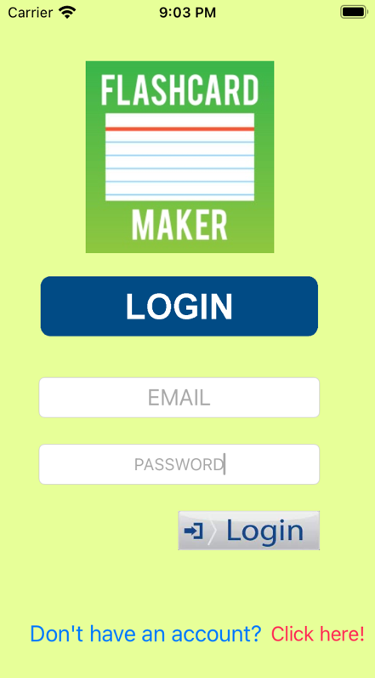
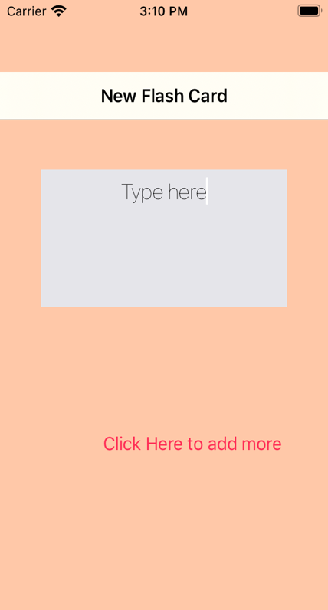
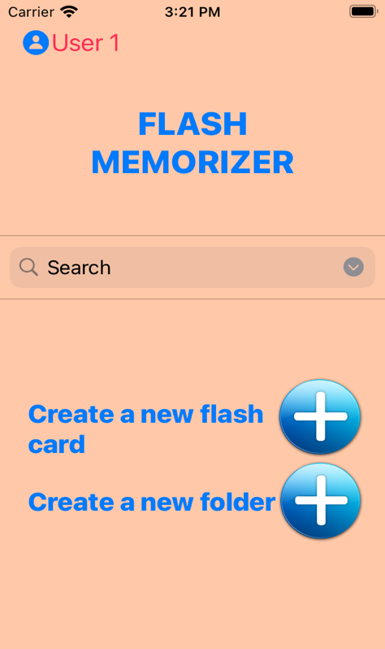

Pic. 1 Login Page Pic. 2 Main Page Pic. 3 Creating Flash card

Pic. 1: Login Page
- On the login page there is the email and password input the allows users to input their required credentials to login into their accounts.
- There is a login button below the password input that allows users to proceed into their accounts after inputting their credentials.
- There is a click here button on the bottom of the page that allows users to proceed to a page that permits users to create a new account.

Pic. 2: Main Page
- On the top left of the main page is an icon/button that indicates the user and allows user to sign out when complete.
- In the center of the page, there is a search bar icon that allows users to type key terms to easily find the group or flash card users are looking for.
- On the bottom part of the page there are two plus icons/buttons that allow users to create and new flash card and folder.

Pic. 3: Creating flash card page
- On the center of the page there is a flashcard template that displayed for users to add their information on.
- On the bottom of the page there is a “click here to add more” button for users to create more flashcards.

4. Glossary
Term | Definition
Users | Refers to people who utilize and interact with the application flash memorize.
Developers | Refers to individuals who develop software, websites, or applications.
IOS | Refers to the operating system of Apple iPhone smart phones.
ANDROID | Refers to the operating system of smart devices such as Samsung smart phones.
PCs | Personal Computers
SRS | Refers to Software Requirements Specifications
Flash Cards | Refers to a card containing a small amount of information, held up for students to see, as an aid to learning.

5. References
Educationalappstore. “10 Best Flashcard Apps to Improve Visual Memory.” Educational App Store, Educational App Store, 1 Dec. 2020, www.educationalappstore.com/best-apps/6-best-flashcard-apps.
Kasiviswanathan, Ashika. “How to Build Login and Sign-up Functionality for Your IOS App Using Firebase within 15 Mins.” Medium, Medium, 1 Mar. 2018, medium.com/@ashikabala01/how-to-build-login-and-sign-up-functionality-for-your-ios-app-using-firebase-within-15-mins-df4731faf2f7.
6. Index

- Introduction
  - Purpose of this product
  - How to use this document
  - Scope of the product
  - Business case for the product
  - Overview of the requirements document
- General Description
  - Product Perspective
  - Product functions
  - User Characteristics
  - General Constraints
  - Assumptions and Dependencies
- Specific Requirements
3.1. User/System Requirements
3.2. Interface Requirements
4. Glossary
5. References
6. Index

